NAMA : ILHAM ANWAR YAZIED

NIM : L200180049

KELAS : B

MODUL : TUGAS MODUL 1

1. LOCAL VARIABLE

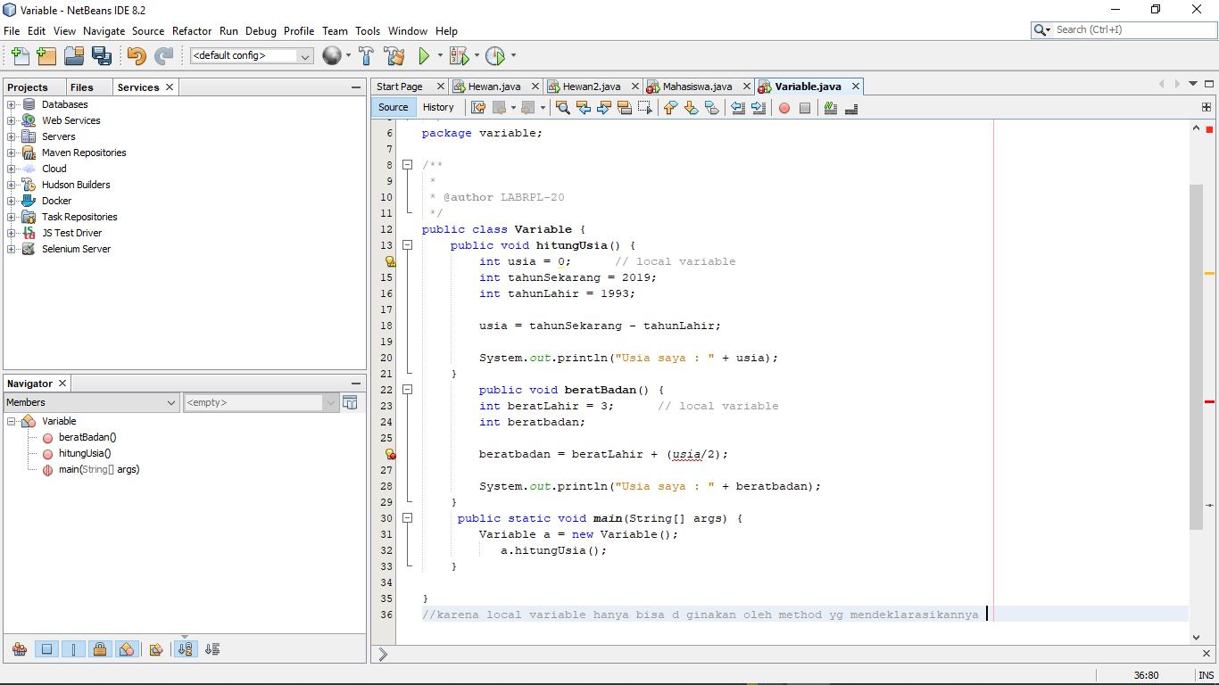

1. INSTANCE VARIABLE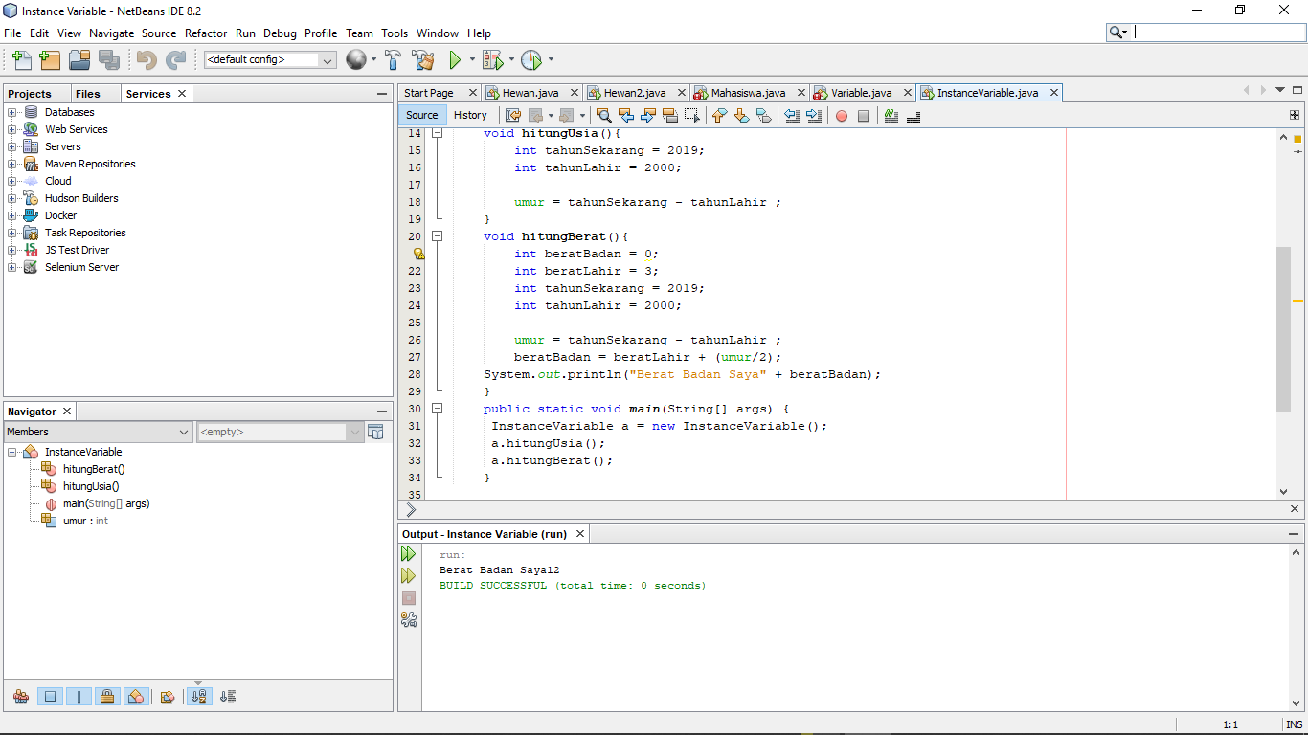
2. Static Variable

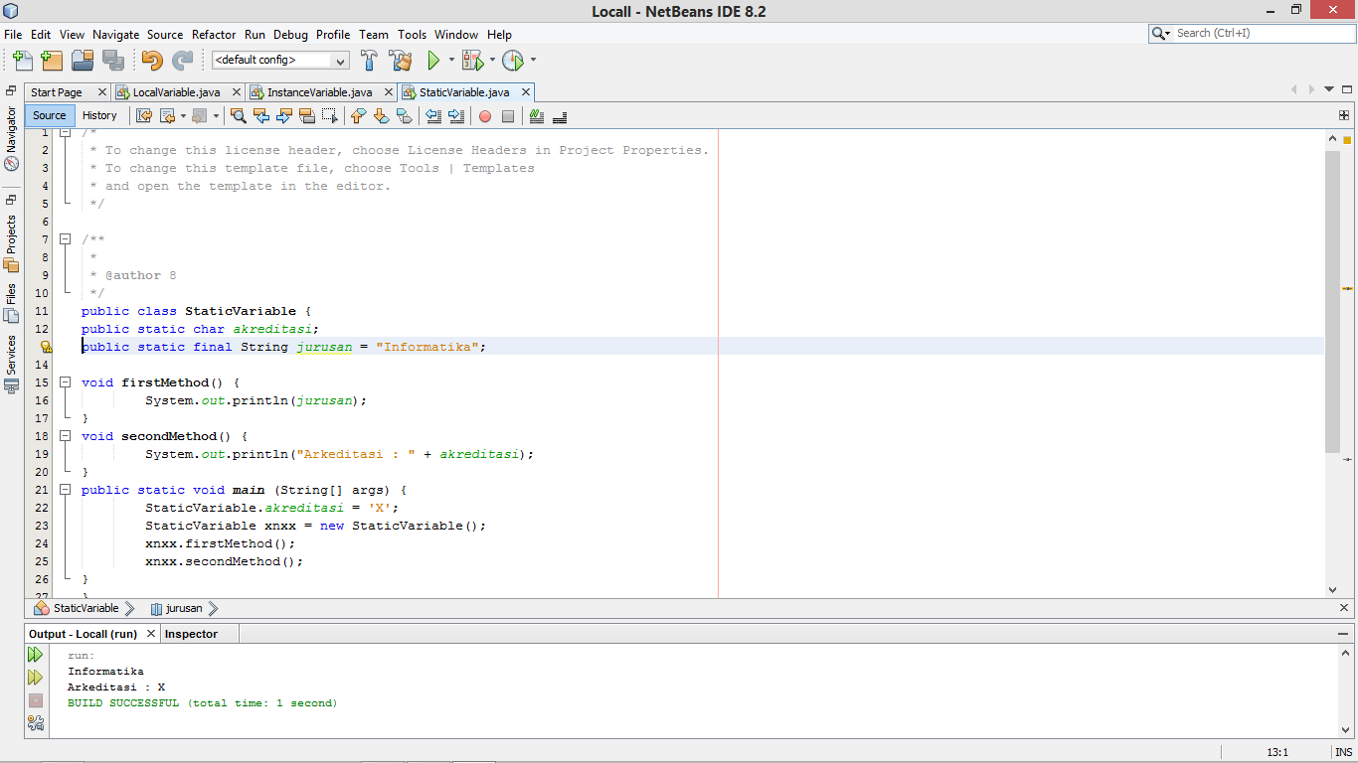

1. Method Non-Void

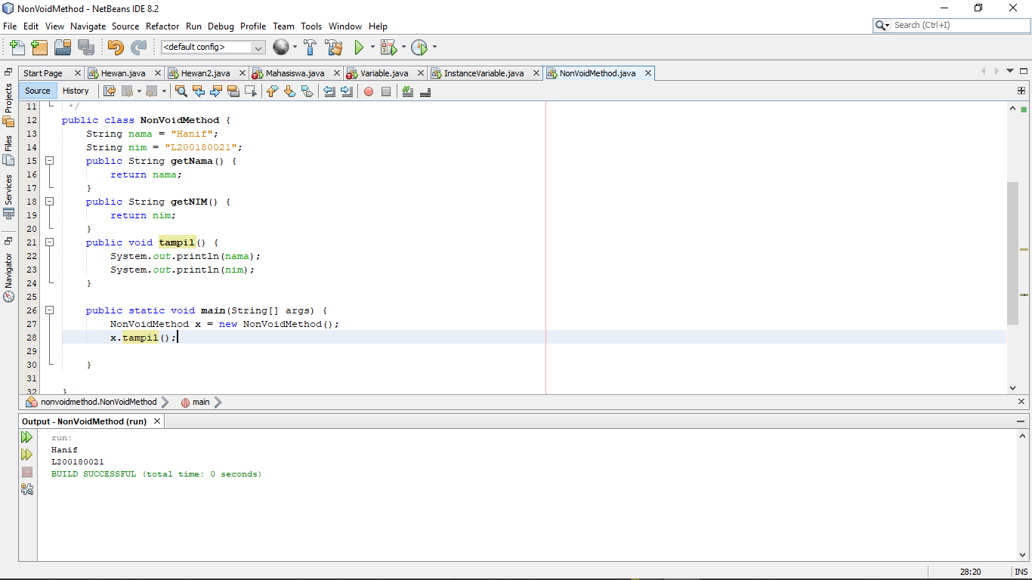

1. Parameter Method

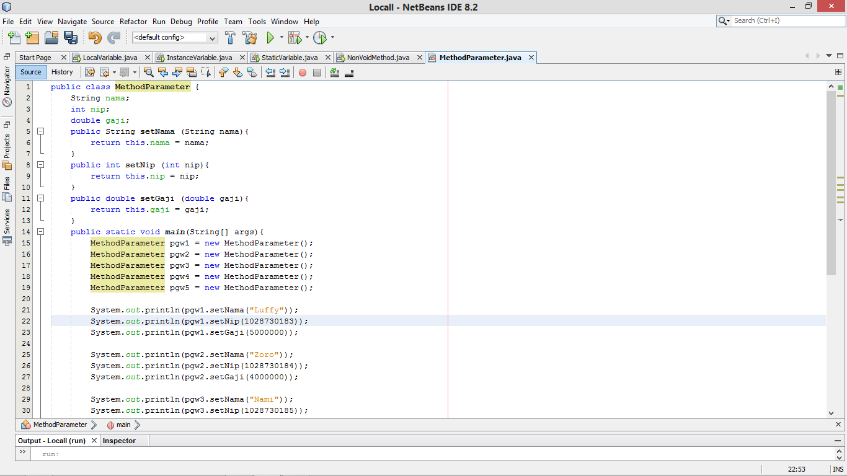

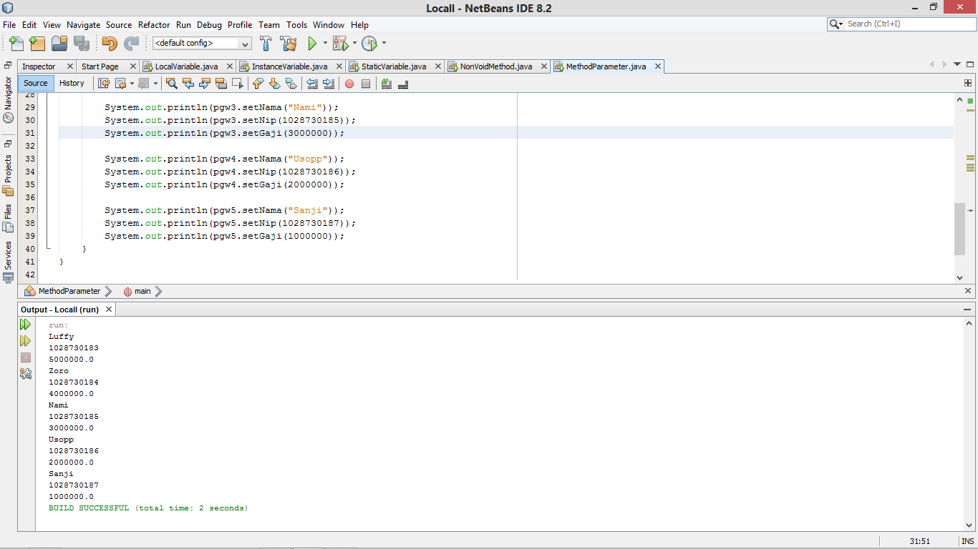

1. Method Void

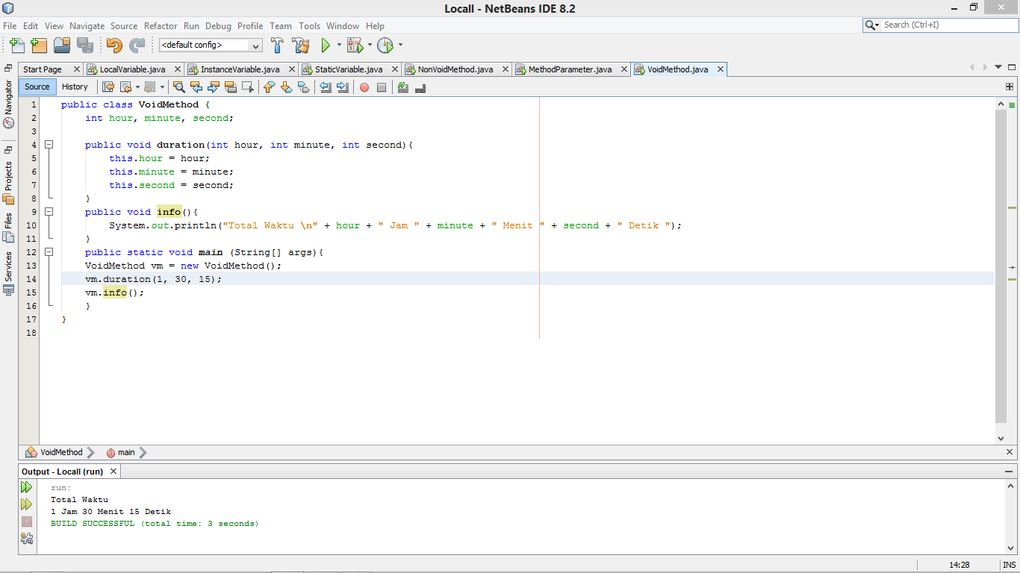

TUGAS

